
Department of Computer Science & Engineering

A Project Report on
A Cognitive Psychology Approach to Analyse Information in Social Network using Machine Learning

Submitted in partial fulfillment of the requirements for the award of the degree of

Bachelor of Engineering in Computer Science & Engineering

By

Aryan Kumar 1MS22CS035
Basavaraj Bhajatri 1MS22CS041
Hariprasad B R 1MS22CS057
I Suprabath Reddy 1MS22CS065

Under the guidance of

Akshata S Bhayyar
Assistant Professor

M S RAMAIAH INSTITUTE OF TECHNOLOGY
(Autonomous Institute, Affiliated to VTU)
BANGALORE-560054
www.msrit.edu
2025

Abstract

This project presents a cognitive psychology-driven conversational AI system for social network analysis, integrating multilingual support and dynamic personality modeling. Leveraging a fine-tuned multilingual BERT (mBERT) model, the chatbot classifies users’ MBTI personality types, analyzes sentiment, and adapts responses using reinforcement learning. Personalized, context-aware interactions are achieved by combining user psychology, sentiment, and conversation history, with real-time translation for cross-linguistic engagement. This approach enables the chatbot to deliver empathetic, adaptive, and culturally relevant responses, advancing the state-of-the-art in personalized conversational AI for diverse user populations.

TABLE OF CONTENTS

Chapter No. Title Page No.

Abstract i

List of Figures
4.1 Schedule of the Project 7
5.1 Use Case Diagram 21
6.1 Class Diagram 24
6.2 User login and Chatbot Interface 25
6.3 Sequence Diagram 28

List of Tables
2.1 Process Organization 3
2.2 Roles and Responsibilities 3
3.2 Relates Works 4

1 INTRODUCTION Page No.
  - General Introduction 1
  - Problem Statement 1
  - Objectives of the project 1
  - Project deliverables 1
  - Current Scope 2
  - Future Scope 2

- PROJECT ORGANIZATION
  - Software Process Models 3
  - Roles and Responsibilities 3

- LITERATURE SURVEY
3.1 Introduction 4
3.2 Related Works with the citation of the References 4
3.3 Conclusion of Survey 6

- PROJECT MANAGEMENT PLAN
  - Schedule of the Project 7
  - Risk Identification 9

- SOFTWARE REQUIREMENT SPECIFICATIONS
5.1 Purpose 11
5.2 Project Scope 11
5.3 Overall description 12
5.3.1 Product perspectives 12
5.3.2 Product features 12
5.3.3 Operating environment 13
5.4 External Interface Requirements 13
5.4.1 User Interfaces 13
5.4.2 Hardware Interfaces 14
5.4.3 Software Interfaces 14
5.4.4 Communication Interfaces 15
5.5 System Features 15
5.5.1 Functional requirements 15
5.5.2 Nonfunctional requirements 17
5.5.3 Use case description 20
5.5.4 Use case diagram 20
- DESIGN
6.1 Introduction 22
6.2 Architecture Design 22
6.3 User Interface Design 24
6.4 Low Level Design 26
6.5 Conclusion 29

CHAPTER 1
INTRODUCTION

1.1 General Introduction
In recent years, social networks have become a major medium for self-expression, emotional sharing, and communication. Understanding the psychological and emotional behavior of users through their online activity is a growing area of interest, especially for developing intelligent systems that can adapt to human needs. This project proposes an AI-based framework that applies cognitive psychology, sentiment analysis and machine learning techniques to analyze user behavior and generate personalized responses in a multilingual setting. By integrating psychological profiling such as MBTI with contextual and emotional insights, the system aims to improve user engagement and conversational relevance.

1.2 Problem Statement
Conventional chatbots often fail to understand the user's personality Dynamically, emotional state, or language preferences, leading to generic and ineffective communication. There is a need for an intelligent system that can analyze user behavior, detect personality traits, and respond meaningfully across different languages and contexts.

1.3 Objectives of the Project
- Dynamic Cognitive Psychology-Based User Classification
Develop a machine learning framework that classifies users into psychological profiles while integrating reinforcement learning to dynamically update personality assessments based on continuous user interactions.
- Personalized Response Generation
Design a chatbot that generates personalized responses by analyzing the user's MBTI personality type, sentiment, and prior conversation context.
- Cross-Linguistic Adaptation
Implement multilingual support by allowing users to select their preferred language at the start, enabling the chatbot to adapt its responses for effective communication across different linguistic backgrounds.

1.4 Project Deliverables
- A chatbot system that:
- Accepts a user’s preferred language.
- Classifies the user’s MBTI personality type.
- Analyzes user sentiment and context from conversation history.
- Generates personalized responses .
- User interaction logs and personality predictions.
- A basic reinforcement learning component to adapt MBTI classification over time.

1.5 Current Scope
- Support for a limited number of languages (e.g., English, Kannada, Hindi).
- MBTI-based classification using ML model.
- Sentiment analysis using pre-trained NLP models.
- Context tracking within a single chat session.

1.6 Future Scope
- Integration of deep learning-based language models for open-ended response generation.
- Automatic language detection and translation without user input.
- Real-time adaptive learning using user feedback loops.
- Expansion to other psychological models beyond MBTI.
- Deployment as a plugin for social networking platforms or mobile apps.

CHAPTER 2

PROJECT MANAGEMENT
2.1 Software Process Models
Software Process Models refers to models like agile , waterfall etc which are applied to project . Different Process Models used in our project are as shown in Table 2.1
Table 2.1 Process Organization
Process Model | Chosen | Justification
Agile Model | Yes | Best suited for dynamic projects like this one where  requirements and insights evolve based on data
Scrum Framework | Yes | Works well with Agile to manage tasks using sprints,  stand-ups, and continuous feedback.
Iterative Model | Yes | Each version of the ML framework improves upon  the previous based on results and evaluation.
Waterfall Model | Partially | Used only for fixed, early-stage phases like requirement gathering and hardware/software planning

2.2 Roles and Responsibilities
Roles and responsibilities refer to the specific duties, tasks, and expectations assigned to individuals or teams within an organization or project as shown in Table 2.2.
Table 2.2 Roles and Responsibilities
Name | Role | Responsibilities
HARIPRASAD B R | Data Engineer | Data collection, cleaning, storage setup
ARYAN KUMAR | Personalized response generation | Analysis of the user on mbti personality type , sentiment and prior conversion
I SUPRABATH REDDY | ML Engineer | Model selection, Training, Tuning
BASAVARAJ BHAJANTRI | Reinforcement learning | Dynamic Cognitive Psychology-Based User Classification

CHAPTER 3
LITERATURE SURVEY
3.1 Introduction to the Literature Survey
In today's digital landscape, technology increasingly mediates our information access, decision-making, and social interactions, yet many systems prioritize technical optimization over psychological compatibility. This literature survey explores an emerging interdisciplinary field that integrates psychological principles into computational systems to create more human-centered technology. By understanding cognitive processes, emotional responses, and social behaviors, researchers are developing systems that work in harmony with human psychology rather than exploiting or ignoring it.
The seven key research papers (2017-2024) reviewed here demonstrate the field's evolution from theoretical foundations in recommender systems to diverse applications addressing critical challenges like cyberbullying detection, misinformation spread, and data overload. These works collectively reveal an important paradigm shift: moving from engagement-focused metrics toward psychological well-being as a design objective, developing more sophisticated methods for implementing psychological insights in technical systems, and increasing attention to the ethical implications of psychologically-informed technology. This integration of machine learning and cognitive psychology promises a digital future where technology enhances human capabilities while respecting cognitive limitations and supporting emotional welfare.

3.2 Related Works
Related works are as shown in the below Table 3.1
Table 3.1 Related Works
SL | Paper | Methodology/Technologies | Performance  Measurement | Values | Comment/ Future
1 | Lex, E., Kowald, D., Seitlinger, P., Tran, T. N. T., & Schedl, M. (2021). Psychology-informed recommender systems. Foundations and Trends® in Information Retrieval, 15(1), 1-87. | Review of psychology theories applied to recommender systems; Integration frameworks for cognitive processes | Survey metrics; Literature review coverage | Interdisciplinary approach; Human-centric design | Foundation work establishing the field of psychology-informed recommender systems
2 | Lex, E., & Schedl, M. (2022). Psychology-informed recommender systems tutorial. Proceedings of the 16th ACM Conference on Recommender Systems (RecSys'22), 1-5. | Tutorial methods; Educational frameworks for psychology-RS integration | Tutorial effectiveness; Knowledge transfer metrics | Educational value; Interdisciplinary knowledge sharing | Focuses on training the next generation of researchers in this interdisciplinary field
3 | Hall, D. L., Silva, Y. N., Wheeler, B., Cheng, L., & Smith, R. (2022). Harnessing the power of interdisciplinary research with psychology-informed cyberbullying detection models. International Journal of Data Science and Analytics, 6(4), 245-263. | Cyberbullying detection models; Social psychology frameworks; NLP techniques | Detection accuracy; False positive rates; Psychological validity | Protection of vulnerable users; Ethical AI implementation | Applies psychological insights to improve detection of harmful content while reducing false positives
4 | Bhowmick, S. S., Chen, S. H. A., & Srivastava, D. (2024). Cognitive psychology meets data management: State of the art and future directions. Companion of the 2024 ACM International Conference on Data Engineering (ICDE'24), 1-8. | Cognitive psychology principles in data management; User cognition models | Data comprehension metrics; Cognitive load measurement | Cognitive accessibility; User understanding | Explores how data management systems can be designed to align with human cognitive processes
5 | Lex, E., & Schedl, M. (2022). Psychology-informed recommender systems: A human-centric perspective on recommender systems. Proceedings of the ACM Conference on Human Information Interaction and Retrieval (CHIIR'22), 1-7. | Human-centric recommender systems; Psychological user modeling | User satisfaction; Decision quality; Psychological well-being | Human autonomy; Mental well-being | Emphasizes designing systems that support rather than manipulate human decision-making
6 | Henry, N. F. (2023). Modelling music selection in everyday life with applications for psychology-informed music recommender systems. Ph.D. Thesis, University of Leeds. | Music selection modeling; Ecological momentary assessment; Context-aware recommendations | Music preference prediction; Situational appropriateness | Personal expression; Emotional well-being | PhD thesis developing models that account for psychological context in music selection
7 | Kumar, A., & Sharma, A. (2021). A review on sentiment analysis and emotion detection from text. Journal of the Indian Institute of Science, 101(4), 435-448. | Sentiment analysis techniques; Emotion detection algorithms; NLP methods | Sentiment classification accuracy; Emotion detection precision | Emotional understanding; Communication quality | Review of text-based approaches to understanding human emotional states

3.3 Conclusion of survey
The Future of Psychology-Informed Systems: A Promising Interdisciplinary Frontier Integrating cognitive and social psychology into computational systems marks a major shift toward more human-centered technology. From early work in psychology-based recommender systems to recent applications in cyberbullying detection, misinformation tracking, and emotional text analysis, this interdisciplinary approach is addressing both technological and societal challenges.
Advancements in neural networks that reflect human memory and cognition are pushing these systems beyond efficiency toward ethical and accessible design. With growing focus on human autonomy, emotional well-being, and information integrity, psychology-informed systems are shaping a future where technology aligns closely with human needs and values.

CHAPTER 4
PROJECT MANAGEMENT PLAN
4.1 Schedule of the project
A Gantt chart is a type of bar chart that illustrates a project schedule, showing the tasks, dependencies, and timelines involved. It's a popular project management tool used to plan, coordinate, and track progress. As shown in Figure 4.1 is the Schedule of the project.
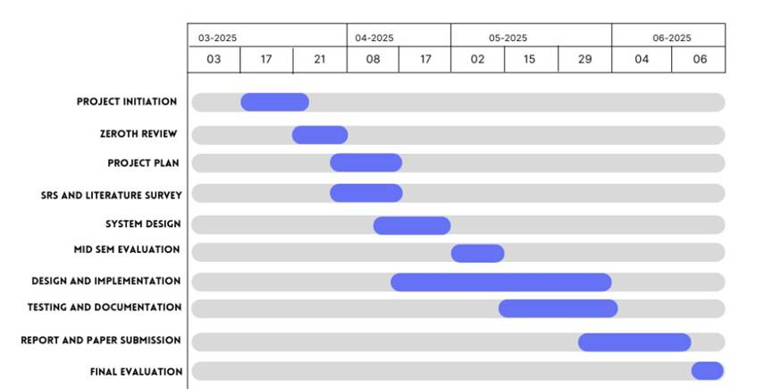
Figure 4.1 Gantt Chart showing the Project Timeline
Project Duration: March 2025 – June 2025
1.Project Initiation (March 3, 2025 – March 21, 2025)
1. Define the scope and goals of the Project.
2. Identify stakeholders and form the core project team.
3. Conduct an initial briefing with the guide.
4. Outline tools, platforms, and hardware to be used.
2. Zeroth Review (March 17, 2025 - March 27, 2025)
1. Present project overview and objectives.
2. Explain Swarm Intelligence and Explainable AI relevance.
3. Gather feedback and refine the plan
3. Project Plan (March 21, 2025 - April 8, 2025)
1. Detail all work phases: planning, development, testing, submission.
2. Define timelines, responsibilities, and dependencies.
3. Finalize risk analysis and contingency strategies
4. SRS and Literature Survey (March 21, 2025 - April 8, 2025)
1. Conduct a thorough literature review on cattle health, XAI, IoT.
2. Prepare Software Requirement Specification (SRS).
3. Identify key system requirements: functional and non-functional
5. System Design (April 8, 2025 – April 17, 2025)
1. Design the architecture of the system.
2. Decide on sensors, data flow, communication protocols.
3. Create system diagrams and UI wireframes for dashboards
6. Mid-Sem Evaluation (May 2, 2025)
1. Present mid-project progress to panel.
2. Demonstrate initial setup or simulation.
3. Review and incorporate feedback into design
7. Design and Implementation (April 8, 2025 – May 29, 2025)
1. Develop data collection pipeline and cloud infrastructure.
2. Implement Explainable AI features
3. Design dashboards.
8. Testing and Documentation (May 15, 2025 – May 29, 2025)
1. Perform system testing.
2. Validate performance and system alerts.
3. Document results, testing protocols, and usage guides
9. Report and Paper Submission (May 29, 2025 - June 4, 2025)
1. Draft and finalize the project report.
2. Prepare a paper summarizing the methodology and results.
3. Submit all materials to internal and external platforms.
10. Final Evaluation (June 4, 2025 - June 6, 2025)
1. Demonstrate the final working solution.
2. Participate in evaluation, including viva and Q&A.
3. Submit source code, report, and presentation decks.
4.2 Risk Identification
Effective risk identification is essential for the success of AI projects that analyze social network data using machine learning and cognitive psychology. Below are the common risks and recommended identification methods specifically tailored for your project:
Common Risks:
- Data Privacy and Ethics:
Non-compliance with privacy laws (e.g., GDPR) or ethical lapses can lead to legal and reputational issues.
- Data Quality and Representativeness:
Social media data can be noisy, incomplete, biased, or unrepresentative, leading to unreliable or skewed analysis results.
- Model Bias and Interpretability:
Machine learning models may inherit or amplify biases from training data, especially when analyzing psychological traits, potentially leading to unfair or misleading conclusions.
- Integration and Scalability Challenges:
Integrating multiple modules (NLP, ML, visualization, chatbot) and scaling to handle large volumes of data can be technically complex.
- Resource Constraints:
Limited computational resources, time, or skilled personnel can delay development or impact system performance.
- Scope Creep:
Uncontrolled expansion of project requirements (e.g., supporting more platforms or psychological models) can lead to missed deadlines or incomplete features.
- Stakeholder Misalignment:
Miscommunication between technical teams and psychology experts may result in misinterpreted requirements or suboptimal system design.
4.2.2 Risk Identification Methods:
- SWOT Analysis:
Assess strengths, weaknesses, opportunities, and threats related to data sources, model design, and deployment environments.
- Root Cause Analysis:
Investigate underlying causes of data quality issues, model errors, or integration failures to prevent recurrence.
- Risk Matrices and Heat Maps:
Visual tools to prioritize risks based on their likelihood and potential impact on project objectives.
- Ethical and Privacy Impact Assessments:
Systematic evaluation of data handling practices, model outputs, and user profiling to ensure compliance and fairness.
- Predictive Analytics:
Use historical project and system logs to forecast potential bottlenecks or failures (e.g., API downtime, data pipeline errors).
- Regular Stakeholder Workshops and Reviews:
Engage all team members (developers, psychologists, end-users) in periodic reviews to proactively identify and address emerging risks.
- Automated Monitoring and Alerts:
Implement real-time monitoring of data pipelines, model performance, and system resources to detect anomalies early.

CHAPTER 5
SOFTWARE REQUIREMENT SPECIFICATIONS
5.1 Purpose
The purpose of this document is to define the software requirements for the system titled “A Cognitive Psychology Approach to Analyze Information in Social Network Using Machine Learning.” This SRS serves as a blueprint that clearly outlines what the software is intended to do, the constraints under which it must operate, and the features it should include.
The system is designed to analyze information dissemination and cognitive behavior on social networks by using machine learning (ML) techniques informed by cognitive psychology. The ultimate goal is to detect behavioral patterns. This document will guide the development team in implementing the desired functionality and will serve as a baseline for validation, verification, and testing.
Intended Audience:
- Software Developers – To build and implement the system as per defined requirements.
- Researchers and Psychologists – To understand how cognitive psychology models are integrated into ML-based social media analysis.
- Project Supervisors and Evaluators – To assess whether the delivered system meets its intended objectives.
- Testers – To create test cases and validate functionality and performance.
5.2 Project Scope
The proposed system is a tool that will analyze user-generated content using Natural Language Processing (NLP) and classification models to extract psychological insights. The software will perform tasks such as sentiment analysis, Personalized response generation and user profiling based on cognitive psychology principles.
The software will:
- Analyze content to detect cognitive distortions, sentiment shifts, and misinformation patterns.
- Classify users dynamically using psychology-inspired machine learning models.
- Provide interactive capabilities through a memory-augmented chatbot.

5.3 Overall Description
This section outlines the general characteristics of the software product, including its context, functionality, and user base. It describes what the system is intended to do from the user’s point of view, highlights its importance, and provides a broad understanding of the expected operating conditions, constraints, and dependencies.

5.3.1 Product Perspective
The proposed system, “A Cognitive Psychology Approach to Analyse Information in Social Network Using Machine Learning,” is a new, self-contained product that does not rely on or extend any existing commercial software systems. It is designed as a standalone analytical tool that integrates machine learning algorithms with cognitive psychology principles to process and interpret social media data.
The system’s components are modular in nature, comprising:
- Data Collection Module
- Preprocessing & NLP Module
- ML-Based Analysis Engine
- Cognitive Profiling System
- Interactive Memory-Augmented Chatbot
- Visualization Dashboard
These components interact in a pipeline-based architecture, where each module’s output serves as input for the next. This modular approach supports reusability and independent updates. The system interfaces only with publicly available APIs and does not require integration with existing enterprise or governmental systems.

5.3.2 Product Functions
The software will provide the following high-level functions:
- Data Scraping and Ingestion: Filters based on language, hashtags, timeframes, or user handles.
- Natural Language Processing and Preprocessing: Performs tokenization, lemmatization, noise removal, and language detection. Identifies sentence structures and emotional tones.
- Sentiment and Bias Analysis: Detects sentiments (positive, negative, neutral). Identifies psychological biases like confirmation bias, framing, anchoring, etc.
- User Profiling Based on Cognitive Patterns: Classifies users into psychological profiles based on their language use and behavioral patterns. Updates profiles over time using reinforcement learning.
- Interactive Visualization: Displays data as graphs, pie charts, and trend lines. Offers downloadable reports and CSV summaries.
- Memory-Augmented Chatbot: Engages with users through a conversational UI. Retains past conversations to improve recommendations and explanations.

5.3.3 Operating Environment
The system is intended to run in the following environment:
- Hardware: Standard desktop/laptop with minimum 8 GB RAM, 2 GHz processor, or hosted on cloud VMs (e.g., AWS EC2).
- Operating Systems:Windows 10/11, Ubuntu 20.04 or later
- Programming Language: Python 3.8+
- Software Dependencies: Scikit-learn, TensorFlow, NLTK, SpaCy, Hugging Face Transformers, Flask or Streamlit for UI/dashboard.
- Database: MongoDB for chatbot memory and user logs
5.4. Interface Requirements
This section outlines how the software interacts with users, hardware, other software components, and communication protocols. It describes all logical and physical interfaces, ensuring smooth and predictable operations of the system within its environment.
5.4.1 User Interfaces
The system will feature a clean, user-friendly Graphical User Interface (GUI) with the following characteristics:
- Signin/Signup dashboard: where the user login to the chatbot interface with credentials.
- Chatbot Interface:Memory-augmented chatbot interface with a chat window and typing bar.Remembers context and offers psychological insights based on user inputs and also personalized response.
- Standard UI Elements
  - Buttons: Submit, Reset, Download Report, Back, Next.
  - Keyboard Shortcuts: (e.g., Ctrl+Enter for submit, Esc to exit screens).
  - Tooltips and Help Popups: Present across all input fields for clarity.
  - Error Messages: Will follow consistent format in pop-up or inline form (e.g., "Invalid input: Please enter a valid keyword.").
- Design Standards:Color scheme: Professional palette (e.g., blue, white, grey).Font: Roboto or Arial, 14pt for normal text, 18pt bold for headings.GUI design will follow standard UI/UX principles and accessibility guidelines (WAI-ARIA).
5.4.2 Hardware Interfaces
The system is designed to run on general-purpose computing hardware. The following hardware interface requirements are defined:
- Client Devices:
  - Standard desktop/laptop systems.
  - Recommended system configuration:
    - CPU: Minimum 2.5 GHz dual-core processor.
    - RAM: 8 GB minimum.
    - Storage: 5 GB free space.
- Optional GPU Support:If running advanced NLP tasks locally, optional GPU acceleration (e.g., NVIDIA CUDA-enabled GPU) is supported for models like BERT.
- Input Devices:Mouse and keyboard.Optional: Microphone (for potential voice-based chatbot integration in future releases).
- Output Devices:Standard displays with minimum 1366×768 resolution.PDF and CSV export options supported via connected printers or file systems.
5.4.3 Software Interfaces
The software interacts with various external software systems, libraries, and APIs. These interfaces include:
- Operating System:Platform-independent; runs on Windows, macOS, or Linux.Recommended: Ubuntu 20.04+ / Windows 10+.
- Programming Languages and Frameworks:Python 3.9+ (primary backend and ML scripting language).MERN (for web-based interface). JavaScript with React (for dynamic frontend components).
- Libraries and Tools:
  - NLP/ML:scikit-learn (v1.3+), TensorFlow (v2.10+), HuggingFace Transformers.
  - Data Handling:pandas, NumPy.
  - Chatbot Memory System:SQLite or TinyDB for session memory storage.
- Databases:MongoDB (preferred for storing structured insights).
- Inter-process Communication:JSON-based messaging format.RESTful endpoints to support modular architecture.
5.4.4 Communications Interfaces
The system communicates with external services and clients through secure and standardized communication protocols.
- Client-Server Communication:RESTful APIs with HTTP/HTTPS protocols.All requests/responses in JSON format.
- Security Measures:Token-based authentication for API access.HTTPS for encrypted transmission.Rate limiting and API key management to prevent abuse.
- Error Handling and Synchronization:Status codes: 200 (OK), 400 (Bad Request), 404 (Not Found), 500 (Internal Server Error).Retry mechanisms for temporary outages or network delays.Sync mechanisms to update client dashboards with latest data in near real-time.
5.5 System Features
This section outlines the major functional capabilities of the system, categorized by user roles. It highlights how different users interact with the software and describes the features that enable these interactions.

5.5.1 Functional Requirements
The functional requirements detail the specific operations and services the system must perform. These are grouped according to different classes of users to ensure role-specific functionality.

5.5.1.1 User Class A: Analyst/Researcher
Analysts or researchers use the system to collect, preprocess, and analyze textual data from the MBTI dataset. Their goal is to extract psychological insights using NLP and machine learning techniques.
i. Data Collection: Enables users to gather and store MBTI-related text data for behavior analysis.
ii. Data Preprocessing :Prepares raw data for analysis by performing cleaning, normalization, and structuring tasks.
Stimulus/Response Sequence:
- Stimulus: User selects a dataset and clicks "Preprocess Data."
- Response: System removes stop words, emojis, URLs, and performs tokenization.
Associated Functional Requirements:
- FR-B1: The system shall clean the text by removing non-textual elements.
- FR-B2: The system shall normalize text (e.g., lowercasing, stemming).
- FR-B3: The system shall validate the output format for compatibility with the NLP pipeline.
iii. NLP and Bias Detection
Uses natural language processing models to detect sentiments and identify cognitive biases such as confirmation bias, framing, or emotional appeals.
Stimulus/Response Sequence:
- Stimulus: User submits cleaned text for analysis.
- Response: System executes NLP and ML models to return sentiment scores and bias classifications.
Associated Functional Requirements:
- FR-C1: The system shall extract sentiment polarity and subjectivity.
- FR-C2: The system shall identify and label cognitive distortions.
- FR-C3: The system shall generate a comprehensive analysis report.
iv. User Profiling via Machine Learning
Creates psychological user profiles based on linguistic patterns and behavioral traits using supervised or reinforcement learning algorithms.
Stimulus/Response Sequence:
- Stimulus: NLP analysis is completed.
- Response: The system classifies users into cognitive archetypes.
Associated Functional Requirements:
- FR-D1: The system shall assign users to cognitive profiles using trained ML models.
- FR-D2: The system shall update user profiles based on new data inputs.
- FR-D3: The system shall securely store user profiles and link them to relevant analysis sessions.

5.5.1.2 User Class B: End-User (Chatbot Interactor)
End-users interact with a memory-augmented chatbot designed to deliver intelligent, context-aware conversations and provide behavior-based insights.
i. Memory-Augmented Chatbot
Presents a conversational interface that incorporates user history for personalized interaction.
Stimulus/Response Sequence:
- Stimulus: User sends a query through the chatbot interface.
- Response: The chatbot retrieves relevant context from memory and provides a personalized response.
Associated Functional Requirements:
- FR-A1: The chatbot shall maintain conversation history for each user.
- FR-A2: The chatbot shall generate personalized responses based on prior interactions.
- FR-A3: The chatbot shall support behavior-based prediction requests.
- FR-A4: The system shall handle unexpected inputs gracefully and maintain error logs.
5.5.2 Non-Functional Requirement
This section outlines the critical non-functional requirements that the system must fulfill to ensure effective performance, security, usability, maintainability, and compliance. While functional requirements describe what the system should do, non-functional attributes describe how well the system should perform under various constraints and conditions.
5.5.2.1 Performance Requirements
These requirements define how the system must perform in terms of speed, resource usage, and responsiveness across various operating conditions.
- Response Time: 95% of sentiment and cognitive label inferences must be completed within 1 second for datasets with fewer than 1000 entries. For larger datasets (1000–10,000 entries), batch processing must complete within 30 seconds on standard server hardware.
- Concurrent Users:The system must support at least 50 concurrent users without performance degradation.For each user, memory consumption must not exceed 200MB during peak usage.
- Throughput:The system should handle at least 10,000 records per hour during peak load scenarios.
- Resource Utilization:CPU usage should not exceed 80% under high load.GPU acceleration (if used) should be leveraged for deep learning-based inference without overloading the server.
- Rationale:Performance is critical for real-time analysis tasks in psychology-focused social media research. Rapid inference and feedback enhance the usability and responsiveness for academic or analyst users.
5.5.2.2 Safety Requirements
These requirements address any potential for harm, misuse, or critical data loss.
- Data Safety:Regular automatic backups must be implemented at 12-hour intervals to prevent data loss.All user-uploaded data must be validated and sanitized before processing to avoid system compromise.
- Access Restrictions:Only authorized users should be able to perform administrative actions like data deletion, model updates, or system reconfiguration.
- Error Handling:The system must fail gracefully with informative error messages and log events when encountering malformed inputs, missing data, or API failures.
- Compliance:The system must comply with data handling standards relevant to academic research involving human data (e.g., IEEE ethics, institutional IRB standards).
5.5.2.3 Security Requirements
Security ensures the protection of data, models, and infrastructure from unauthorized access, manipulation, or breaches.
- Authentication:Multi-level authentication must be implemented (e.g., role-based login for Admin, Analyst, and Viewer).Passwords must be stored using strong encryption algorithms (e.g., bcrypt or SHA-256 with salting).
- Data Privacy:Personally Identifiable Information (PII) must never be stored.All data must be anonymized and handled in accordance with GDPR-like data protection principles.
- Data Transmission:All data exchanges between client and server must be secured using HTTPS with valid SSL certificates.
- Vulnerability Protection:The system must be protected against common security threats (e.g., SQL injection, XSS, CSRF) using input sanitization and secure coding practices.
- Security Auditing:Logs of all access and administrative operations must be maintained for auditing.
5.5.2.4 Software Quality Attributes
These describe the overarching quality factors that enhance the user and developer experience:
- Reliability:The system must maintain 99% uptime with automatic recovery from crashes.A watchdog process should be used to restart crashed services if necessary.
- Usability:The user interface should be intuitive with tooltips, help sections, and graphical representations (e.g., charts, word clouds).Cognitive results must be clearly labeled and interpreted for non-technical users.
- Portability:The system must be easily deployable on different environments using Docker containers. All components should support Linux, Windows, and Mac systems for development.
- Maintainability: The codebase should follow modular architecture to allow independent updates to the UI, backend, or ML models.Inline documentation and README files must be maintained with every component.
- Reusability:ML model modules and data processing pipelines should be structured as reusable Python classes or functions.
- Testability:Unit tests must be written for at least 80% of backend functionality.GUI and integration tests should be conducted using tools like Selenium or PyTest.
- Scalability:The system must support horizontal scaling using container orchestration (e.g., Kubernetes) for handling high-load scenarios.
5.5.3.5 Business Rules
These rules govern the logical and procedural flow of how the system is used based on roles and responsibilities.
- Role-Based Access Control (RBAC):
  - Viewer:Can view processed results and reports only.
- Usage Policies:
  - No user may upload or process illegal, offensive, or hate-driven content. Automated keyword filters will flag such data.
  - Analysts must agree to a data ethics disclaimer before using the tool.
- Data Retention:
  - Uploaded datasets will be retained for a maximum of 30 days unless explicitly saved by the user.
  - Temporary files and cache must be cleared periodically to avoid storage overuse.
5.5.3 Use case description
The Personality-Based Multilingual Chatbot Interaction use case describes the process through which an end-user engages with a conversational system capable of delivering intelligent, psychologically informed, and multilingual responses. The interaction begins with the user selecting a preferred language, after which the chatbot predicts the user’s MBTI personality type using natural language processing and machine learning techniques. This personality profiling informs subsequent steps, such as sentiment and context analysis, enabling the chatbot to understand the user’s emotional state and the intent behind the message. Based on this analysis, the system generates personalized responses that reflect both the user’s psychological profile and the evolving context of the conversation. A reinforcement learning component is employed to enhance the chatbot’s behavior over time based on user interactions and feedback. Additionally, user data is securely collected to continuously update cognitive profiles for better personalization. This use case facilitates a dynamic, user-aware interaction model, as illustrated in Figure 5.1 Use Case Diagram for Personality-Based Multilingual Chatbot Interaction.

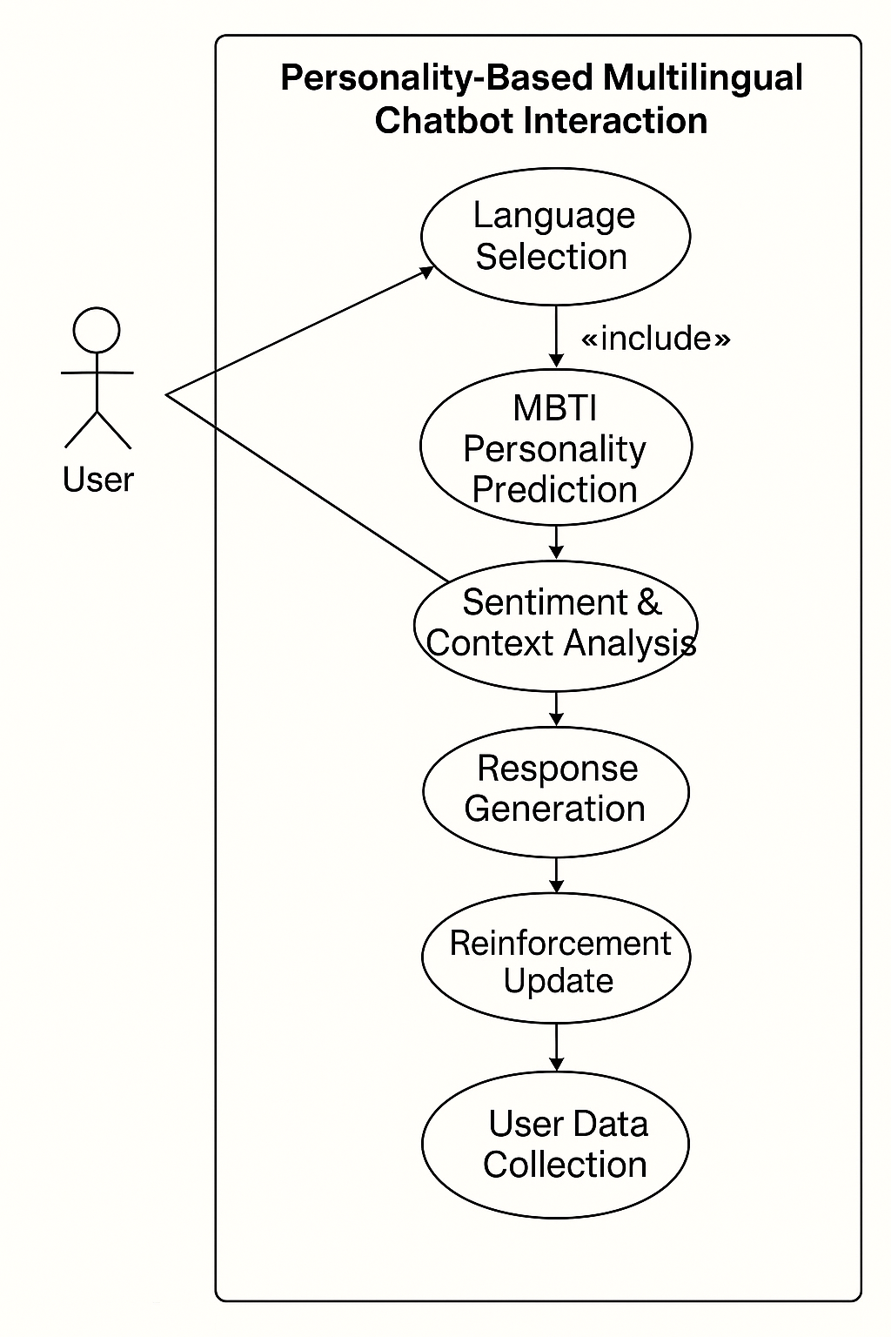
Figure 5.1 Use Case Diagram
CHAPTER 6
DESIGN
6.1 Introduction
Social networks have become integral to modern communication, generating vast amounts of data that contain valuable insights into human behavior and psychology. This project aims to analyze social network information through a cognitive psychology lens using machine learning techniques. By combining principles from psychology with advanced data analysis, we seek to understand how users interact online, identify cognitive biases, detect misinformation, and analyze emotional patterns across social media platforms. Our modular layered architecture integrates data acquisition, preprocessing, analysis and chatbot interaction to provide meaningful insights into user behavior. The system is designed to classify users based on their cognitive profiles, detect various types of biases in content, analyze sentiment and emotions across different languages, and provide interactive visualizations for better understanding of the data. The memory-augmented chatbot adapts to individual psychological profiles, maintaining personalized interactions based on historical data. This interdisciplinary approach bridges the gap between technology and psychology, offering deeper insights into how information spreads and influences people on social media. The project addresses the growing need for more sophisticated tools to understand human behavior in digital spaces, especially considering the rapid spread of information and misinformation online. By leveraging machine learning algorithms alongside psychological frameworks, our system aims to provide a more nuanced understanding of social network dynamics.

6.2 Architecture Design
To enable advanced behavioral analysis, the architecture is built using a modular layered approach. It ensures separation of concerns across stages like data processing, psychological analysis and chatbot interaction. This structure not only promotes maintainability and scalability but also facilitates seamless integration of cognitive models and machine learning algorithms for accurate and adaptive user insights.

6.2.1 Selected Architectural Style: Modular Layered Architecture
The Modular Layered Architecture is chosen to separate concerns in the system, enhance maintainability, and allow for easier scaling. Each layer handles a specific responsibility—from data acquisition to personalized response—enabling better abstraction and modular development. This architecture is ideal for a data-driven project like ours, which incorporates psychological modeling, machine learning, and social network analysis.

6.2.2 Key Characteristics of Modular Layered Architecture
- Separation of Concerns:The application is divided into clearly defined layers such as Data Ingestion, Preprocessing, Analysis (ML/Cognitive), Interaction Layer (Chatbot). This ensures clarity and ease of development and testing.
- Scalability: Each layer can be independently scaled based on load. For instance, the analysis layer with deep learning models may require more computational resources and can be deployed on GPU-powered servers.
- Maintainability: As each module has distinct functionality, making changes to one component does not affect others. This facilitates quick iterations and upgrades.
- Reusability: Modules like the Cognitive Bias Detection or Language Processor can be reused across different projects with minimal changes.
- Extensibility: Future enhancements like integrating advanced LLMs or additional personality profiling models can be added without impacting the rest of the architecture

6.2.3 Components of the Architecture
Figure 6.1 illustrates the object-oriented class diagram of the system, highlighting core modules such as UserProfile, AnalyzerEngine, MemoryChatbot, LanguageProcessor along with their relationships.
- Language Processor: Allows users to select the desired language.
- Data Acquisition Layer: Captures and stores data (posts, interactions, metadata) through chatbot from user request.
- Preprocessing Layer: Performs text normalization, tokenization, language detection, and cleaning.
- Analysis Layer: as follows
  - User Classification Module: Uses machine learning and reinforcement learning to dynamically classify users into cognitive psychology-based profiles.
  - Sentiment Analysis: Detects mood, tone, and sentiment across languages using NLP and psychological heuristics.
  - Personalized Response generator: based on the user profile analysis
- Chatbot Interaction Layer: A memory-augmented chatbot that adapts based on historical data and cognitive profiles to maintain personalized interactions.
- Database Layer: Stores raw data, processed features, user profiles, and analysis outputs using scalable storage like PostgreSQL or MongoDB.
- Reinforcement Learning component : That Allows the Dynamic Cognitive Psychology-Based User Classification.
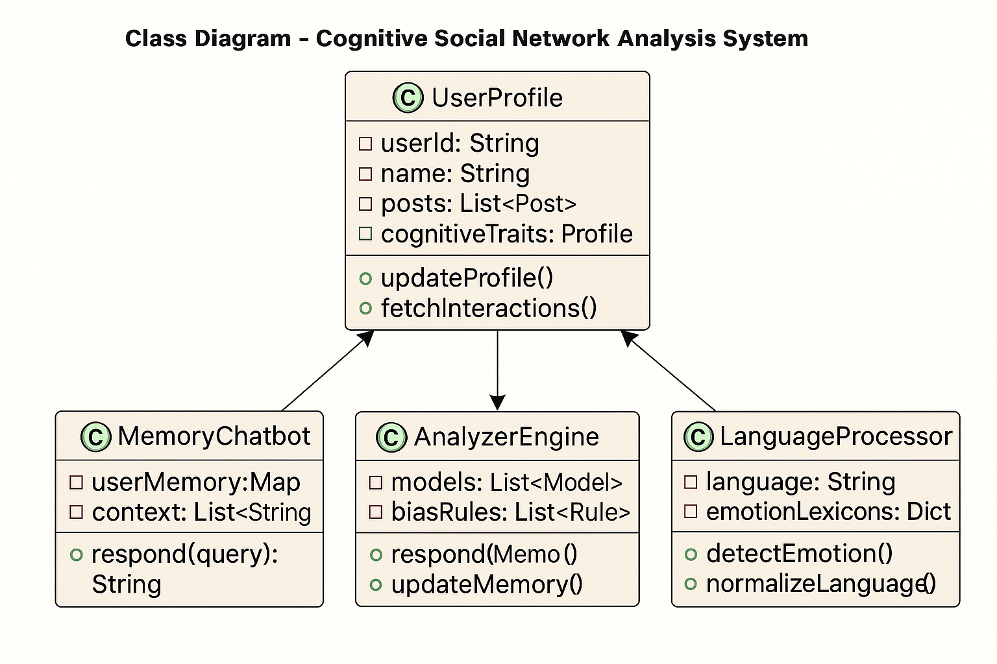
Figure 6.1 Class Diagram

6.3 User Interface Design
The User Interface (UI) of the Cognitive Psychology-Based Social Network Analysis System is designed to provide a clear, insightful, and accessible experience for decision-makers. Given the complexity and sensitivity of analyzing human emotions, the UI emphasizes on psychological transparency, and user-guided exploration of insights

6.3.1 Design Philosophy

Psychology-Centric: The system interface aligns with human psychological behavior by presenting emotionally intelligent cues, cognitive bias indicators, and sentiment-driven trends in a digestible manner.
- Data Scientist Friendly: It provides in-depth access to user classification models, sentiment progression.
- Responsive and Modular: Optimized for both desktop and mobile, supporting seamless usage across platforms in real-time analysis environments.
- Accessible to All: Inclusive design using readable fonts, high-contrast color schemes, multilingual support, and icon-based navigation to ensure usability across diverse audiences.

6.3.2 UI Layout Overview :The application is structured into the following core interface
- User Setting and Language Control
- Sentiment Analysis Feed
- Cognitive Chatbot Panel
Figure 6.2 shows the chatbot interface and the user login .Each screen includes a consistent top navigation bar, central visual data panels, and a side or bottom panel for tools, export options, and real-time notifications.
.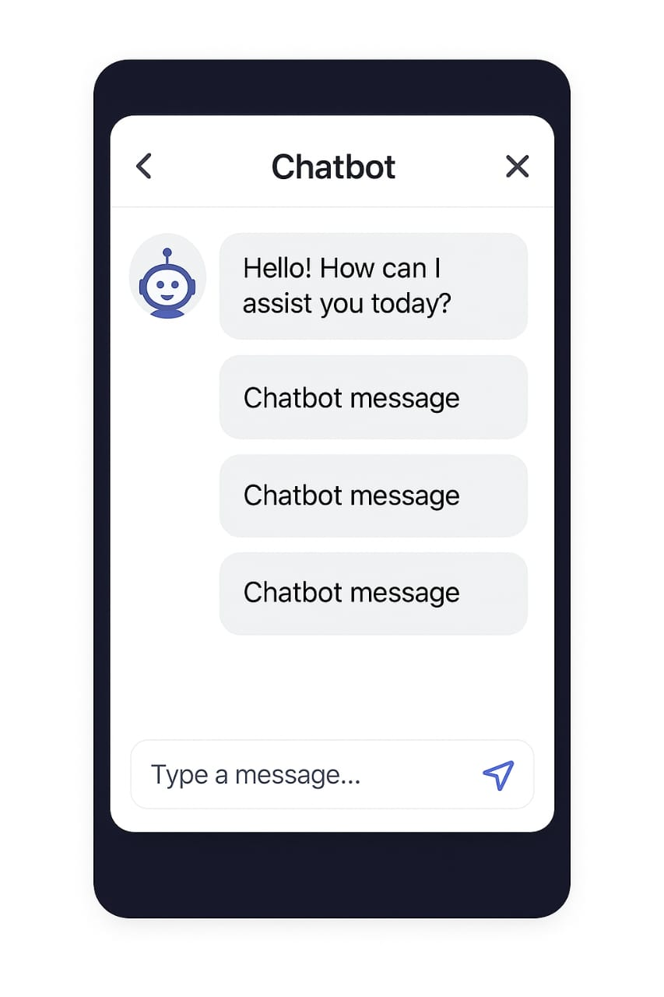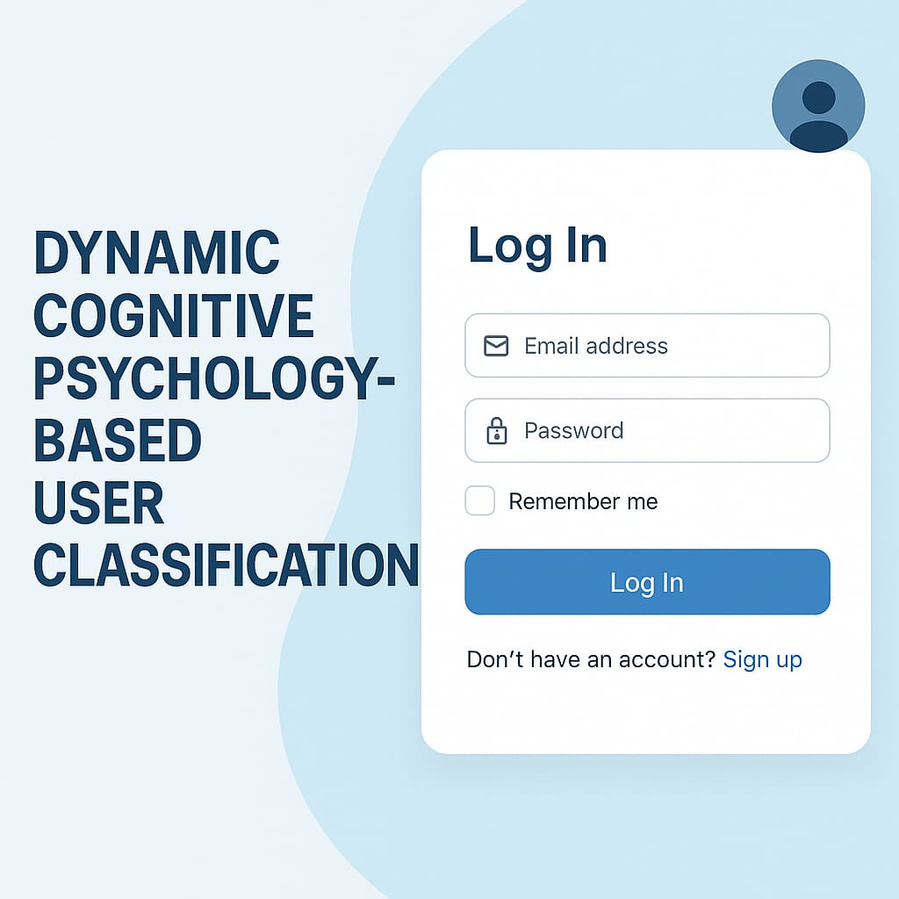
Figure 6.2 User login and the chatbot interface

6.3.3 Key Screens and Components: Following are the Components with explanation
- Sentiment Feed :Feed-style UI showing analyzed user text. Each text is tagged with sentiment (e.g., joy, fear, anger) .
- Cognitive Chatbot Pane:AI-powered memory-augmented chatbot. Responds to queries with psychological insight. Stores user logs for adaptive response patterns.
- Reinforcement learning component : Dynamic Cognitive Psychology-Based User Classification
- Language Selection : user selects the desired language .
- Personalized response generator: based on the user mbti type, user chat history and the sentiment analysis
6.3.4 Design Tools and Libraries
- Real-Time Engine: WebSocket + Flask-SocketIO
- Frontend Framework: React.js
- Visualization Libraries: D3.js, Chart.js
- Chat Layer: Rasa / Dialog flow for chatbot
- Styling: Tailwind CSS, Material UI
6.4 Low Level Design
The low-level design outlines the technical implementation details of our cognitive psychology-based social network analysis system. It maps the interactions and data flows within each module, connecting psychological principles with machine learning components. The accompanying diagrams visualize the processing sequences and state transitions necessary for developers to implement the system effectively.

MBTI Chatbot Sequence Flow Description
The following sequence diagram Figure 6.3 captures the end-to-end interaction flow between the user and various system components in the MBTI-based multilingual chatbot. It outlines how messages are processed, how personality and sentiment are analyzed, and how responses are dynamically generated using reinforcement learning.

Components Involved:
- User: Initiates conversations with the chatbot and provides feedback based on responses, influencing personalization and learning.
- UI/Interface:Serves as the frontend through which users interact, enabling login, language selection, and real-time chat display.
- Authentication Service: Processes sign-in/sign-up requests and interacts with the database to verify or create secure user accounts.
- Chatbot Engine:Handles the core logic of message processing and response generation using personality and sentiment insights.
- ML Analysis Service:Analyzes user input to determine MBTI personality type and emotional sentiment, returning structured results.
- Reinforcement Learning Module:Optimizes chatbot responses based on user feedback by updating internal learning parameters over time.
- Database:Stores user credentials, chat history, personality profiles, preferences, and reinforcement learning data.
The MBTI chatbot system begins with user authentication, where a user initiates a sign-up or login request through the user interface. These credentials are securely forwarded to the Authentication Service, which interacts with the database to either verify existing credentials or create a new user profile. The result of this authentication process is sent back to the interface and appropriately displayed to the user. Once authenticated, the user selects their preferred language, which the interface stores in the database. Upon confirmation, the UI updates dynamically to reflect the selected language, ensuring a personalized and accessible user experience.
With the language preference set, the user initiates a conversation by sending a message through the interface, which is then forwarded to the Chatbot Engine. As part of the initial interaction, the engine requests an MBTI personality prediction from the ML Analysis Service. This module analyzes the user’s text and returns a corresponding MBTI type. Following this, a sentiment analysis is performed to determine the emotional tone of the input. Both results are stored in the database to ensure that the most accurate and current personality profile is used for tailoring responses.
In the response generation phase, the Chatbot Engine leverages both personality and sentiment data to craft a personalized reply. To enhance this process, it consults the Reinforcement Learning Module, which retrieves learning parameters from the database, applies optimization strategies, and returns a refined version of the response. This final personalized response is delivered back to the user through the interface, ensuring relevance and psychological alignment.
The system then enters a continuous learning loop where the user may keep interacting or provide feedback. Any feedback is passed through the interface to the Chatbot Engine and then to the Reinforcement Learning Module. This module updates its Q-values based on the feedback and stores the revised learning parameters in the database. This ongoing feedback mechanism allows the chatbot to adapt its behavior over time, leading to more intelligent, empathetic, and user-aligned interactions.

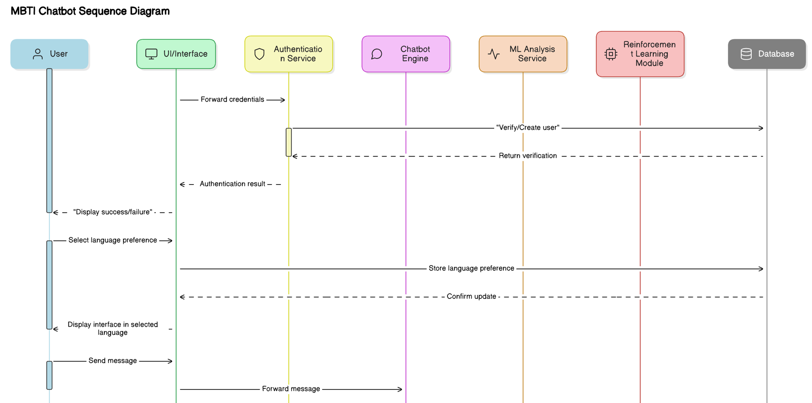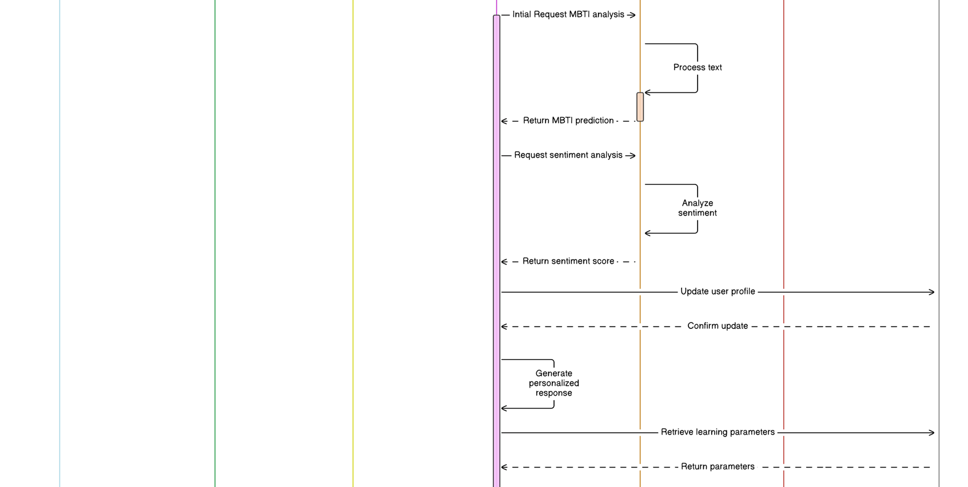
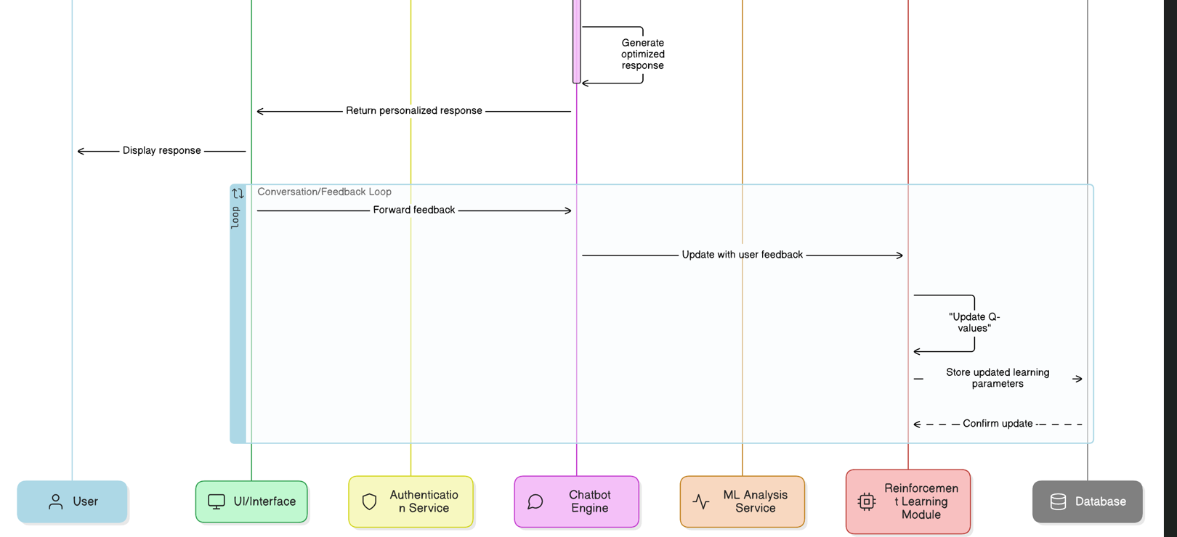
Figure 6.3 Sequence diagram of the chatbot
6.5 Conclusion
This project successfully demonstrates the integration of cognitive psychology principles with machine learning techniques to analyze social network information. Our modular layered architecture effectively processes social media data through various stages from acquisition and preprocessing to analysis and visualization enabling comprehensive understanding of user behavior patterns, cognitive biases, and emotional expressions. The memory enhanced chatbot and adaptive user classification provide personalized insights that evolve over time, while the cross-linguistic emotion recognition capabilities ensure analysis across diverse cultural contexts. These features collectively offer valuable tools for researchers, analysts, and decision-makers to understand psychological aspects of social media interactions. The system's ability to identify cognitive biases and misinformation helps address critical issues in today's digital information ecosystem. Our user interface design emphasizes psychology-centric visualization, making complex psychological data accessible to both technical and non-technical users. The implementation of reinforcement learning enables the system to continuously improve its classification accuracy and adapt to changing user behaviors. The cross-linguistic capabilities make the system particularly valuable in diverse cultural contexts like India, where multiple languages are used on social platforms. As social networks continue to evolve, this system provides a foundation for more nuanced understanding of human behavior online, with potential applications in misinformation detection, emotional wellbeing analysis, and personalized digital experiences. Future work could expand the system to incorporate more advanced psychological models and additional language support to further enhance its analytical capabilities

